# Abstract

This Document summarizes the requirements for cable and connector selection as well as routing for SLS 2.0 and all new installations in other facilities of PSI utilizing EtherCAT based motion control and simple IO.

The guideline will define strict requirements, indicated by the word ‘**must**’ or ‘**mandatory**’, as well as strong suggestions indicated by the word ‘**should**’. Weak requirements are indicated by the word ‘**preferred**’.

This guideline describes devices operated in air, under normal environmental conditions (298 K (25°C), 1013 mbar, 50 % rH) no or low radiation. Exceptions apply for devices operated in any other environments including, but not limited to, vacuum, low temperature, strong magnetic fields or high radiation. Common exceptions are described in the respective sections.

# General Rules

## Patching

* A patch panel is mandatory.
* For larger devices, multiple patch panels are allowed. The placement should allow easy access during operation. The placement is subject to discussion during the design phase and has to be approved by PSI during the final design review (FDR).

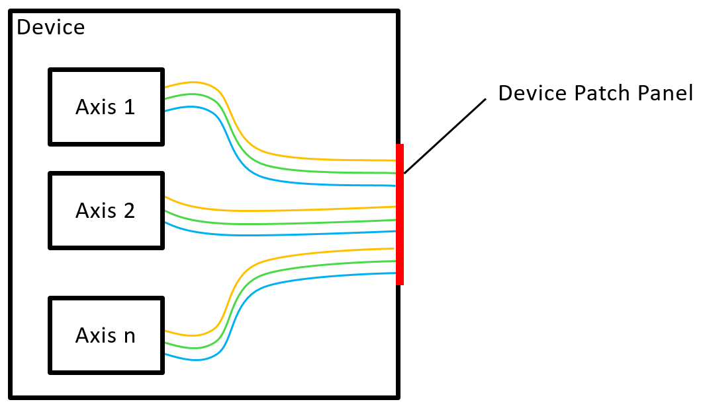

## Degree of Protection

Connectors must be encapsulated or protected from direct access/touch. Minimum IP2X according to IEC standard 60529

## Cable Routing

* A strain relief of all cables is mandatory.
* The minimum bending radius of all cables must be obeyed.
* Moving components should feature a drag chain or other mechanical feature to ensure clean and repeatable guiding of cables.

## Shielding

* All cables and connectors must be shielded.

## Protective Earth (PE)

* The patch panel must be electrically connected to PE star point with sufficient cross section.

## Documentation

* A wiring diagram with all connectors and cables must be provided.
* All connectors and cables must be labeled according to the wiring diagram.
* The BOM of the CAD assembly should indicate the utilized connector type, vendor and part number. Alternatively, a separate list of components should be provided.

# Connectors and Cables

In this section, the connector types as well as the pinouts are defined. Any deviation for the subsequently listed requirements must be approved by PSI prior to the FDR.

Exception: For devices operated in vacuum- or other vessels with feedthroughs, a direct cable routing from the respective feedthrough to the patch panel must be realized. The feedthroughs should not share signals with potential cross talk, i.e. motor and thermocouple. The selection of the feedthrough is subject of the manufacturer, except for thermocouples. The latter have to approved by PSI individually deepening on application.

## Connector overview (Device Patch Panel)

|  |  |  |  |  |  |  |
| --- | --- | --- | --- | --- | --- | --- |
|  | Stepper | Encoder | Limits | Pt-100 | TC* | Requirement |
| Connector type | M12 | | | | | must |
| Coding | A | | | | | must |
| Contacts | 4 | 8 | 5 | 5 | 5 | must |
| Shielding | Yes | Yes | Yes | Yes | Yes | must |
| Connector locking system | Crimp | Crimp | Crimp | Crimp | Crimp | should |

*Thermocouple

## Stepper Motors

Only Beckhoff cables should be used due to the larger conductor cross section, compared to standard M12 cables. Alternatively, custom manufactured cables with sufficient cross section can be used.

### Pin assignment for stepper motors

|  |  |  |
| --- | --- | --- |
| Pin | Signal | Colors |
| 1 | A | brown |
| 2 | A/ | white |
| 3 | B | blue |
| 4 | B/ | black |

### How to connect a Beckhoff AS1000 series stepper

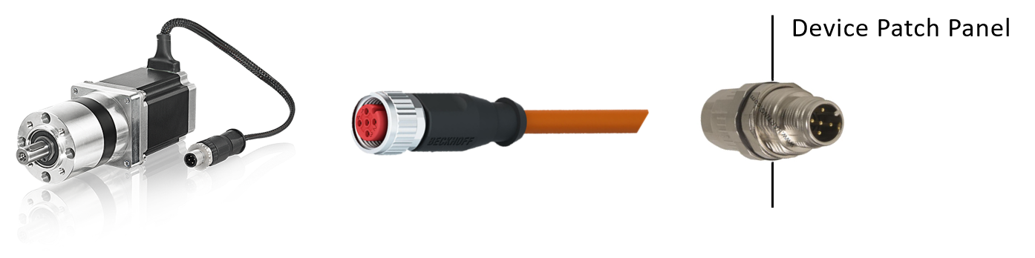

Stepper: Beckhoff AS1000 Series (comes with assembled M12 connector)  
Extension Cable: Beckhoff ZK4000-6200-2xxx  
Panel Feed Through: Harting 21 03 821 1525

### How to connect a Beckhoff AS2000 series stepper

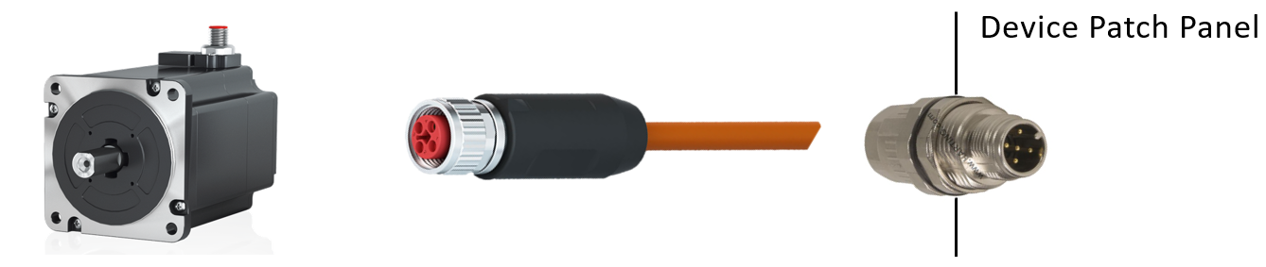

Stepper: Beckhoff AS2000 Series (M12, T-coded, connector on motor)  
Extension Cable: Beckhoff ZK4000-7700-0xxx  
Panel Feed Through: Harting 21 03 821 1525

### How to connect a motor with flying leads

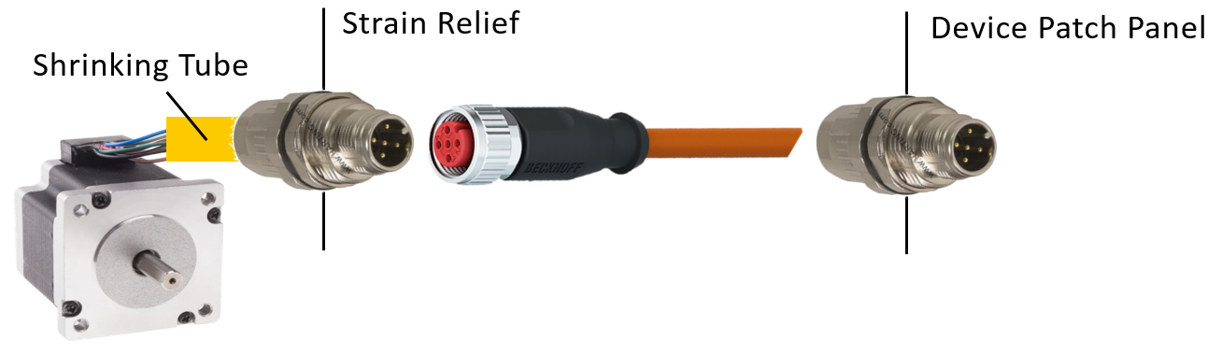

Stepper: Any manufacturer  
Extension Cable: Beckhoff ZK4000-6200-2xxx  
Panel Feed Through: Harting 21 03 821 1525

## Encoders

All encoders must be absolute. The information length should be restricted to 26 bit for linear encoders or 12/13 bit for multi turn rotary encoders. Higher information length has to be approved by PSI. Any other encoder type also has to be approved by PSI with a detailed description why the afore defined requirements cannot be met.

### Pin assignment Encoders

|  |  |  |  |
| --- | --- | --- | --- |
| Pin | Signal BiSS-C | Signal SSI | Colors |
| 1 | 0 V | 0 V | white |
| 2 | V+ | V+ | brown |
| 3 | MA + | Clock + | green |
| 4 | MA - | Clock - | yellow |
| 5 | SLO + | Data + | gray |
| 6 | SLO - | Data - | pink |
| 7 | Set | Set | blue |
| 8 | Direction | Direction | red |

### How to connect an Encoder with matching pin assignment (1:1)

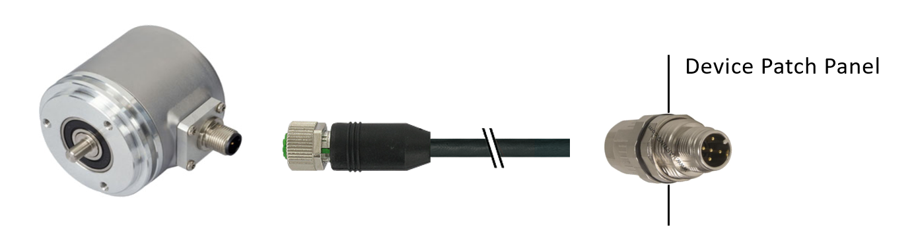

Encoder: Any Manufacturer  
Extension Cable Phoenix Contact 1522888  
Panel Feed Through: Harting 21 03 821 1825

### How to connect an Encoder with non-matching pin assignment

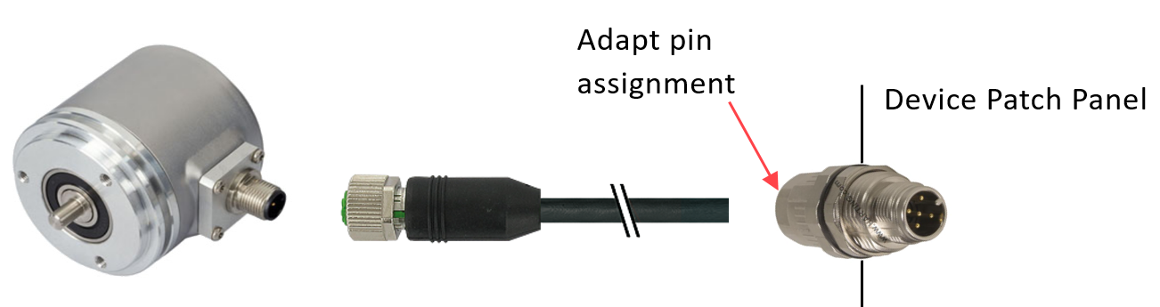

Encoder: Any Manufacturer  
Extension Cable Any Manufacturer  
Panel Feed Through: Harting 21 03 821 1825

## Limit switches/sensors

All limit switches must be tolerant to 24 VDC. Active sensors must be of PNP type. Mechanical switches must be normally closed (NC). Any deviation from those requirements have to be approved by PSI. Negative (backward) and positive (forward) limit switches should be connected to one connector. Use a T- or Y –splitter to split the signal for the individual switches. The use of M8 switches is preferred, M12 is allowed, flying leads should be avoided.

### Pin assignment for limit switches (on device patch panel)

|  |  |  |
| --- | --- | --- |
| Pin | Signal | Colors |
| 1 | V+ | brown |
| 2 | Negative Limit | white |
| 3 | GND | black |
| 4 | Positive Limit | blue |
| 5 | Output (e.g. brake) | gray |

### Pin assignment for limit switches (M8 connector)

|  |  |  |
| --- | --- | --- |
| Pin | Signal | Colors |
| 1 | V+ | brown |
| 2 | n.c. |  |
| 3 | GND | blue |
| 4 | Signal | black |

### How to connect sensors with M8 connector

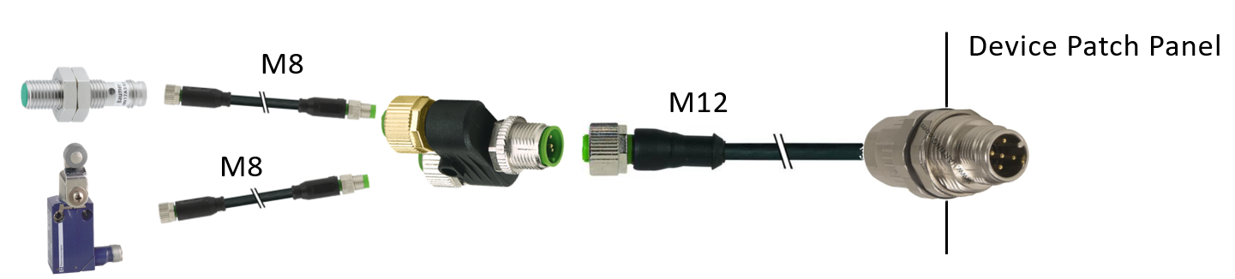

Limit Switches: Any manufacturer  
Extension cable M8: Phoenix Contact 1456310  
T-Splitter: Murr Electronics 7000-41201  
Extension Cable M12: Phoenix Contact 1682951  
Panel Feed Through: Harting 21 03 821 1525

### How to connect sensors with flying leads

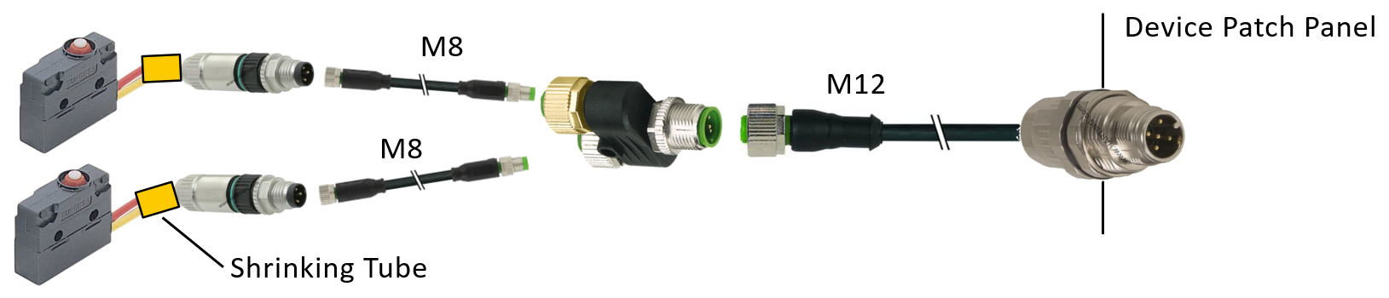

Limit Switches: Any manufacturer  
M8 Connecotr: Harting 21 02 151 1305  
Extension cable M8: Phoenix Contact 1456310  
T-Splitter: Murr Electronics 7000-41201  
Extension Cable M12: Phoenix Contact 1682951  
Panel Feed Through: Harting 21 03 821 1525

**Alternatively, use patch box instead of T-Splitter**

## Temperature measurement

### Pin assignment for Pt-100

|  |  |  |
| --- | --- | --- |
| Pin | Signal | Colors |
| 1 | RL + | brown |
| 2 | R | white |
| 3 | RL - | black |
| 4 | R - | blue |
| 5 | Shield | gray |

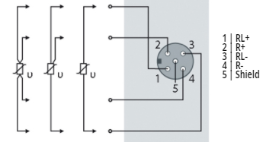

### Pin assignment for thermocouples

|  |  |
| --- | --- |
| Pin | Signal |
| 1 | Compensation A |
| 2 | Input + |
| 3 | GND |
| 4 | Input - |
| 5 | Shield |

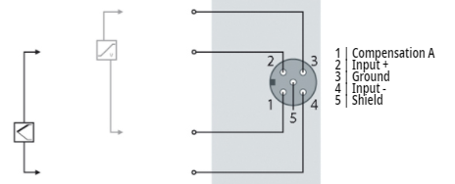

# List of sources

Harting

RS-online (stepper flying leads)

Beckhoff

Posital

Baumer

Saia

Murr

Phoenix Contact